October 1, 2017

Christopher Greer

Candiadte number: 184521

Cost Estimator

Contents

Screen Design 2

JSP 2

Pseudo Code 3

Program Code 4

Testing 4

Error Messages for incorrect values 4

Proof of Operation 4

Proof 1 4

Proof 2 4

Proof 3 4

Proof 4 4

Proof 5 4

Proof 6 4

Evaluation 4

# Screen Design

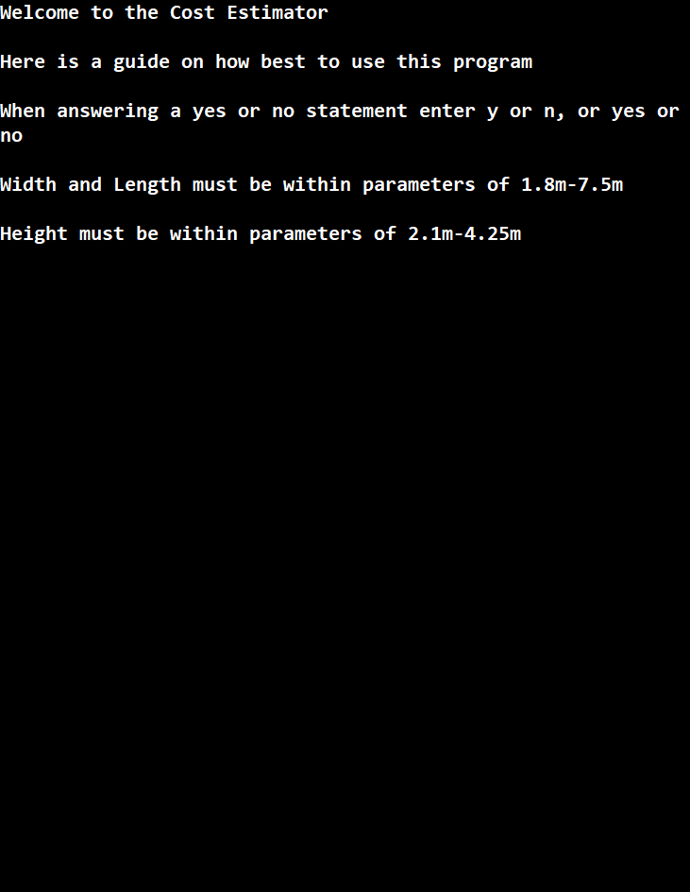

This is the screen showing the opening statement of my program which shall welcome the user to the program and introduce them to the rules and guidelines of the program. If any bugs or problems arise I can also add work arounds to this list.

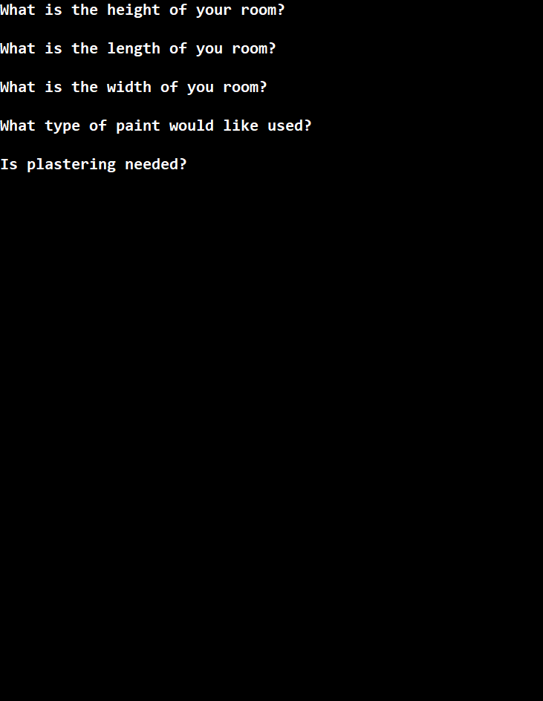

This screen is the one where values

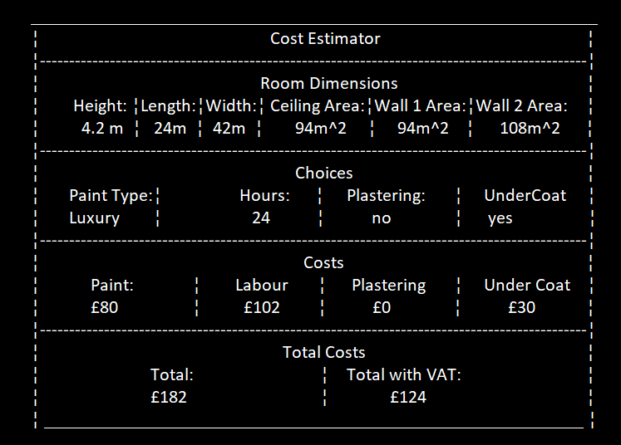

The Screen design is very basic as C has no way of creating a GUI outside of the console window that is created when it is run. Therefore, I have constructed a table that reads in the order that the information was given. This allows the user to see exactly what they inputted, what was calculated and the total costs of each item. The total is then displayed at the bottom with and without VAT just in case they wanted all the information.

# JSP

The following shows my JSP diagram which was done by hand as it allowed more accuracy and less tedious box moving when reshuffling the order of the program.

# Pseudo Code

Enter Variables

height=What is the height of your room?

If height>4.25, height<2.1

Print error in height value

length=What is the length of your room?

If length>7.5, length<1.8

Print error in length value

width=What is the width of your room?

If width>7.5, width<1.8

Print error in width value

paintType=What type of paint do you want? Luxury,Standard,Economy

If value is not one of the options

Print error in given option

plastering=Is plastering needed? Yes or No

If value is not yes, no or an abbreviation

Print error in given option

underCoat=Is an undercoat needed? Yes or No

If value is not yes, no or an abbreviation

Print error in given option

hoursNeeded=How many hours are required?

return height,length,width,paintType,plastering,undercoat,hoursNeeded

Ceiling Area

ceilingArea=width*length

return ceilingArea

Wall 1 Area

w1=length*height

wall1Area=w1*2

return w1,wall1Area

Wall 2 Area

W2=width*height

wall2Area=w2*2

return w2,wall2Area

Plastering Cost

If plastering=yes

P1=ceilingArea*31

P2=wall1Area*22.55

P3=wall2Area*22.55

plasteringCost=P1+P2+P3

return plasteringCost

Paint Cost

If paintType=Luxury

paint=3

If paintType=Standard

paint=1.45

If paintType=Economy

paint=0.75

return paint

Painting Cost

c1=ceilingArea*paint

c2=wall1Area*paint

c3=wall2Area*paint

paintingCost=c1+c2+c3

Hours Cost

hCost=hoursNeeded*17.5

if hCost<120

hcost=120

return hCost

Undercoat Cost

If undercoat cost=yes

tArea=ceilingArea+wall1Area+wall2Area

uCost=tArea*0.5

Total

t=hCost+paintingCost+plasteringCost+uCost

total=t*1.2

return total,t

Print Info

Print__________________________________________________________

Print ¦ Cost Estimator ¦

Print ¦------------------------------------------------------------------------------------------¦

Print ¦ Room Dimensions ¦

Print ¦ Height: ¦Length:¦Width:¦ Ceiling Area:¦Wall 1 Area:¦Wall 2 Area: ¦

Print ¦ height ¦length ¦ width ¦ ceilingArea ¦ wall1Area ¦ wall2Area ¦

Print ¦------------------------------------------------------------------------------------------¦

Print ¦ Choices ¦

Print ¦ Paint: ¦ Labour ¦ Plastering ¦ Under Coat ¦

Print ¦ paintType ¦ hoursNeeded¦ plastering ¦ undercoat ¦

Print ¦ ------------------------------------------------------------------------------------------¦

Print ¦ Costs ¦

Print ¦ Paint: ¦ Labour ¦ Plastering ¦ Under Coat ¦

Print ¦ paintingcost ¦ hCost ¦ plasteringCost ¦ uCost ¦

Print ¦ ------------------------------------------------------------------------------------------¦

Print ¦ Total Costs ¦

Print ¦ Total: ¦ Total with VAT: ¦

Print ¦ t ¦ total ¦

Print ¦_______________________________________________________ ¦

# Program Code

# /***********************************************************************

# * test.c

# * Estimates the cost of a job for an interior decorator

# * Christopher Greer, candidate number:184521

# * October 2017

# * ********************************************************************/

# #include <stdio.h>

# #include <stdlib.h>

# float getLength(void);

# float getHeight(void);

# float getWidth(void);

# char getPaint(void);

# char getPlastering(void);

# char getUndercoat(void);

# float getHours(void);

# float ceilingArea(float width,float length);

# float wall1Area(float length,float height);

# float wall2Area(float width,float height);

# float plasteringFunc(float ceilingArea,float Area1,float Area2, char plastering);

# float paintCost(char paintType);

# float paintingCost(float cArea,float Area1,float Area2, float paint, float width, float length, float height);

# float hoursCost(float hoursNeeded);

# float undercoatCost(char underCoat,float cArea,float Area1,float Area2,float width, float length,float height);

# float Total(float hCost,float pCost,float plasteringCost,float uCost);

# float totalFinal(float t);

# int printInfo();

# int main(void)

# {

# 

# 

# /*This is where all welcome infomation is displayed*/

# printf("Welcome to the Cost Estimator\n");

# printf("The idea of this program is to work out the cost of decorating the given room.\n\n\n");

# printf("Here is a guide on how best to use this program:\n");

# printf("1. When answering a yes or no statement enter y or n instead of yes or no\n");

# printf("2. Width and Length must be within parameters of 1.8m-7.5m\n");

# printf("3. Height must be within parameters of 2.1m-4.25m\n\n");

# 

# printInfo();

# return 0;

# }

# /*Below is the function to get the height*/

# float getHeight(void)

# {

# float height;

# printf("\nWhat is the height of your room?");

# scanf("%f",&height);

# 

# if(height>4.25)

# {printf("Not within parameters of 2.1m-4.25m\a\n");

# exit(0);

# }

# if(height<2.1)

# {printf("Not within parameters of 2.1m-4.25m\a\n");

# exit(0);

# }

# return height;

# }

# /*Below is the function to get the length*/

# float getLength(void)

# {

# float length;

# printf("\nWhat is the length of you room?");

# scanf("%f",&length);

# if(length<1.8)

# {printf("Not within parameters of 1.8m-7.5m\a\n");

# exit(0);

# }

# if(length>7.5)

# {printf("Not within parameters of 1.8m-7.5m\a\n");

# exit(0);

# }

# return length;

# }

# /*Below is the function to get the width*/

# float getWidth(void)

# {

# float width;

# printf("\nWhat is the width of you room?");

# scanf("%f",&width);

# if(width<1.8)

# {printf("Not within parameters of 1.8m-7.5m\a\n");

# exit(0);

# }

# if(width>7.5)

# {printf("Not within parameters of 1.8m-7.5m\a\n");

# exit(0);

# }

# return width;

# }

# /*Below is the function to get the type of paint*/

# char getPaint(void)

# {

# char l[0], paintType;

# printf("\nWhat type of paint would like used?");

# printf("\nLuxury(l), Standard (s) or Economy (e)");

# scanf("%s",&l);

# 

# paintType=l[0];

# paintCost(paintType);

# return paintType;

# }

# /*Below is the function to see whether plastering is needed*/

# char getPlastering(void)

# {

# char p[0],plastering;

# printf("\nIs plastering needed?");

# printf("\nYes=y No=n");

# scanf(" %s", &p);

# if (p[0]=='y')

# {

# return 'y';

# }

# else if (p[0]=='n')

# {

# return 'n';

# }

# else

# {

# printf("Wrong input for Plastering");

# getPlastering();

# }

# 

# 

# plastering=p[0];

# return plastering;

# }

# /*Below is the function to see whether an Undercoat is needed*/

# char getUndercoat(void)

# {

# char uc[0],underCoat;

# printf("\nIs undercoating needed?");

# printf("\nYes=y No=n");

# scanf(" %c", &uc);

# if (uc[0]=='y')

# {

# return 'y';

# }

# else if (uc[0]=='n')

# {

# return 'n';

# }

# else

# {

# printf("Wrong input for underCoat");

# getUndercoat();

# }

# 

# underCoat=uc[0];

# printf("%c",underCoat);

# return underCoat;

# }

# /*Below is the function to see how many hours are needed*/

# float getHours(void)

# {

# float hoursNeeded,h;

# printf("\nHow long will it take?\n In hours?");

# scanf("%f",&h);

# hoursNeeded=h;

# return hoursNeeded;

# }

# /*This function calculates the area of the ceiling*/

# float ceilingArea(float width,float length)

# {

# float cArea;

# cArea=width*length;

# return cArea;

# }

# /*This function calculates the area of a wall*/

# float wall1Area(float length,float height)

# {

# float Area1;

# Area1=(length*height)*2;

# return Area1;

# }

# /*This function calculates the area of the other wall*/

# float wall2Area(float width,float height)

# {

# float Area2;

# Area2=(width*height)*2;

# return Area2;

# }

# /*This function calculates the cost of the plastering*/

# float plasteringFunc(float cArea,float Area1,float Area2, char plastering)

# {

# float plasteringCost,P1,P2,P3;

# char p;

# p=plastering;

# if (p=='y')

# {

# plasteringCost=(cArea*31)+(Area1*22.55)+(Area2*22.55);

# return plasteringCost;

# }

# else if (p=='n')

# {

# return 0;

# }

# else

# {

# printf("Wrong input for plastering");

# getPlastering();

# }

# return p;

# }

# /*This function works out what paint type was given*/

# float paintCost(char paintType)

# {

# float paint;

# if (paintType=='l')

# {

# return 3;

# }

# else if (paintType=='s')

# {

# return 1.45;

# }

# else if (paintType=='e')

# {

# return 0.75;

# }

# else

# {

# printf("Wrong input for paint type");

# getPaint();

# }

# }

# /*This function calculates the cost of the painting*/

# float paintingCost(float cArea,float Area1,float Area2,float paint,float width, float length, float height)

# {

# float c1,c2,c3,pCost,p;

# p=Area1+Area2+cArea;

# pCost=p*paint;

# return pCost;

# }

# /*This function calculates the cost of labour*/

# float hoursCost(float hoursNeeded)

# {

# float hCost;

# char q;

# hCost=hoursNeeded*17.5;

# if (hCost<120)

# {

# hCost=120;

# }

# else if (hoursNeeded>99)

# {

# printf("This exceeds the maximum amount of hours.\n");

# printf("Are you sure you want to do this?");

# scanf("%s",&q);

# if (q=='y')

# {

# hCost=hoursNeeded*17.5;

# return hCost;

# }

# else

# {

# hoursNeeded=getHours();

# }

# }

# return hCost;

# }

# /*This function calculates the cost of the undercoat*/

# float undercoatCost(char underCoat,float cArea,float Area1,float Area2,float width, float length,float height)

# {

# float uCost,tArea;

# char uc;

# cArea=ceilingArea(width,length);

# Area1=wall1Area(length,height);

# Area2=wall2Area(width,height);

# uc=underCoat;

# if (uc=='y')

# {

# tArea=cArea+Area1+Area2;

# uCost=tArea*0.5;

# return uCost;

# }

# else if (uc='n')

# {

# return 0;

# }

# else

# {

# printf("Wrong input for underCoat");

# getUndercoat();

# }

# }

# /*This function adds up all of the costs to give a total*/

# float Total(float hCost,float pCost,float plasteringCost,float uCost)

# {

# float t;

# t=hCost+pCost+plasteringCost+uCost;

# return t;

# }

# /*This function takes the total and adds the VAT*/

# float totalFinal(float t)

# {

# float totalF;

# totalF=t*1.2;

# return totalF;

# }

# /*This function displays all of the information in a format that can be easily read*/

# int printInfo()

# {

# char pound=156 ;

# /*This is where the main Variables are defined*/

# float width, length, height, plasteringCost, paint, hoursNeeded, hCost, uCost, Area1, Area2, cArea,

# pCost, totalF, t;

# char plastering, paintType, underCoat;

# 

# /*Here is where all of the seperate funcions are called and variables assigned*/

# paintType=getPaint();

# paint=paintCost(paintType);

# plastering=getPlastering();

# underCoat=getUndercoat();

# hoursNeeded=getHours();

# hCost=hoursCost(hoursNeeded);

# length=getLength();

# height=getHeight();

# width=getWidth();

# uCost=undercoatCost(underCoat,cArea,Area1,Area2,width,length,height);

# cArea=ceilingArea(width,length);

# Area1=wall1Area(length,height);

# Area2=wall2Area(width,height);

# plasteringCost=plasteringFunc(cArea,Area1,Area2,plastering);

# pCost=paintingCost(cArea,Area1,Area2,paint,width,length,height);

# t=Total(hCost,pCost,plasteringCost,uCost);

# totalF=totalFinal(t);

# printf("_______________________________________________________________\n");

# printf("] Cost Estimator [\n");

# printf("]--------------------------------------------------------------[\n");

# printf("][ Room Dimensions ][\n");

# printf("][Height][Length][Width][Ceiling Area][Wall Area1][Wall Area2][\n");

# printf("][ %.2fm][%.2f m][%.2fm][ %.2f m^2 ][ %.2f m^2 ][ %.2f m^2 ][\n",

# height,length,width,cArea,Area1/2,Area2/2);

# printf("]--------------------------------------------------------------[\n");

# printf("][ Choices ][\n");

# printf("][ PaintType ][ Hours ][ Plastering ][ UnderCoat ][\n");

# printf("][ %c ][ %.1f ][ %c ][ %c ][\n",

# paintType,hoursNeeded,plastering,underCoat);

# printf("]--------------------------------------------------------------[\n");

# printf("][ Costs ][\n");

# printf("][ Paint ][ Labour ][ Plastering ][ UnderCoat ][\n");

# printf("][ %c%.2f ][ %c%.2f ][ %c%.2f ][ %c%.2f ][\n",

# pound,pCost,pound,hoursCost(hoursNeeded),pound,plasteringCost,pound,uCost);

# printf("]--------------------------------------------------------------[\n");

# printf("][ Total Costs ][\n");

# printf("][ Total: ][ Total with VAT: ][\n");

# printf("][ %c%.2f ][ %c%.2f ][\n",

# pound,t,pound,totalF);

# printf("_______________________________________________________________\n");

# return 0;

# }

# Testing

## Error Messages for incorrect values

When a value for the height is entered outside of the values 2.1m-4.25m an alarm sound played via “\a” in the print function and the following message was displayed

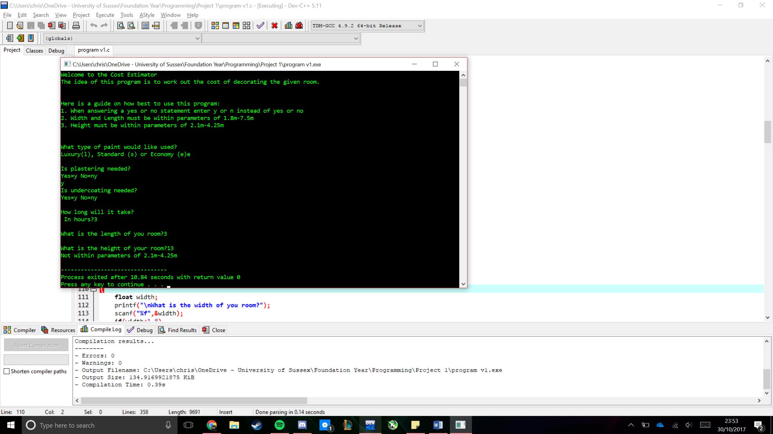

When a value for the length is outside of the intended values of 1.8m-7.5m an alarm sounds and the following is displayed in the console.

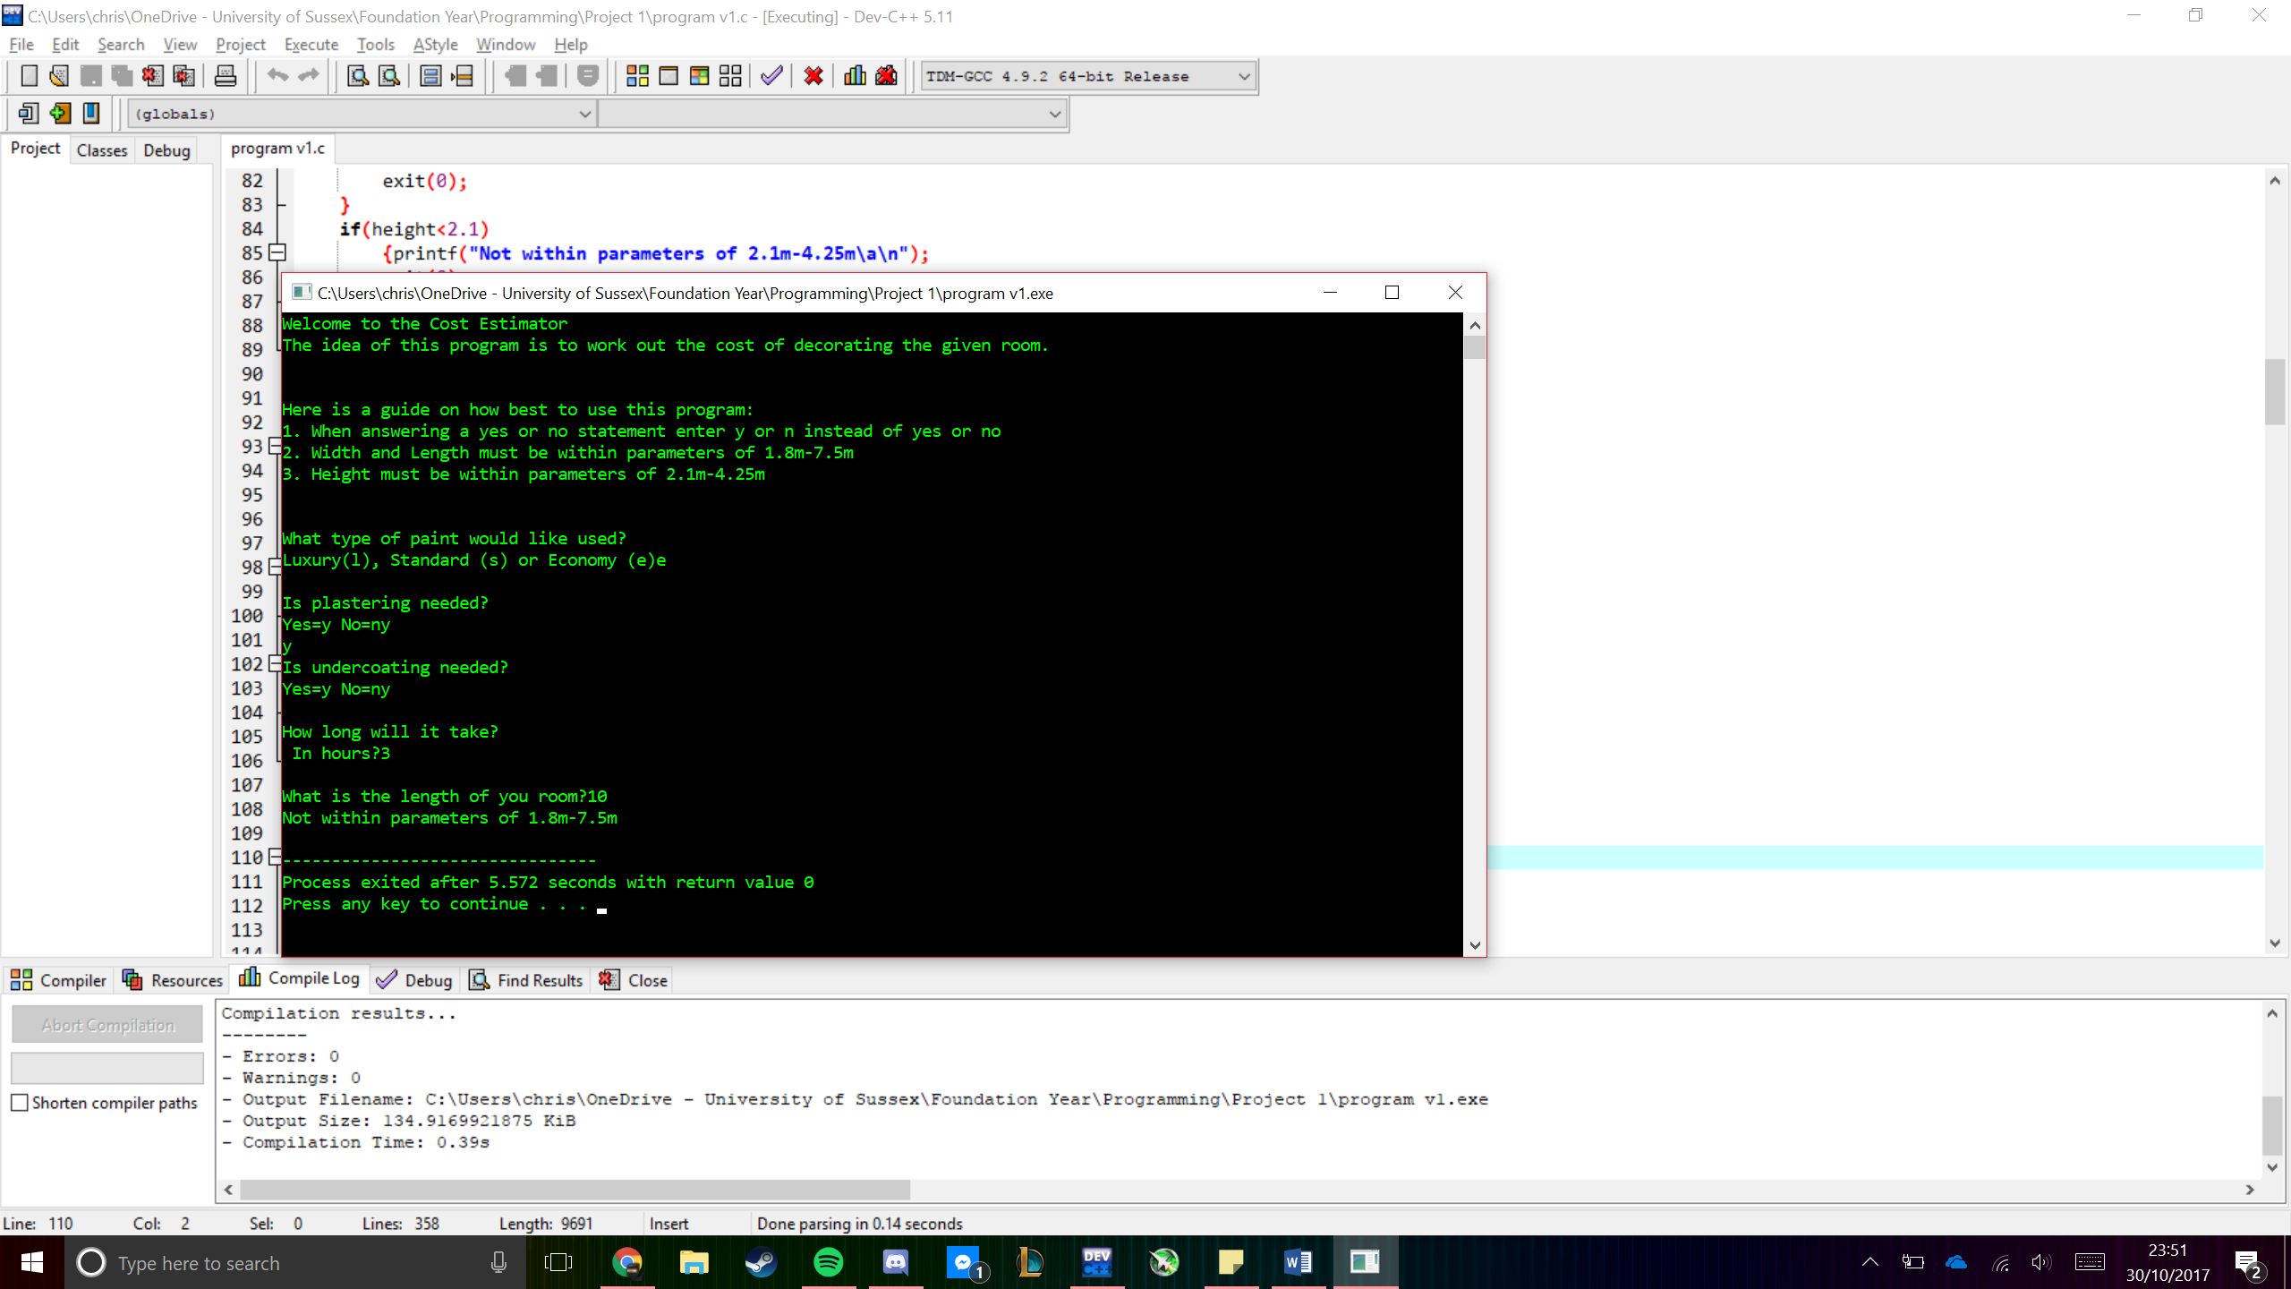

After entering an integer or value for the width of the room that is outside of the supposed range of 1.8m-7.5m a sound plays and the following is displayed to the user.

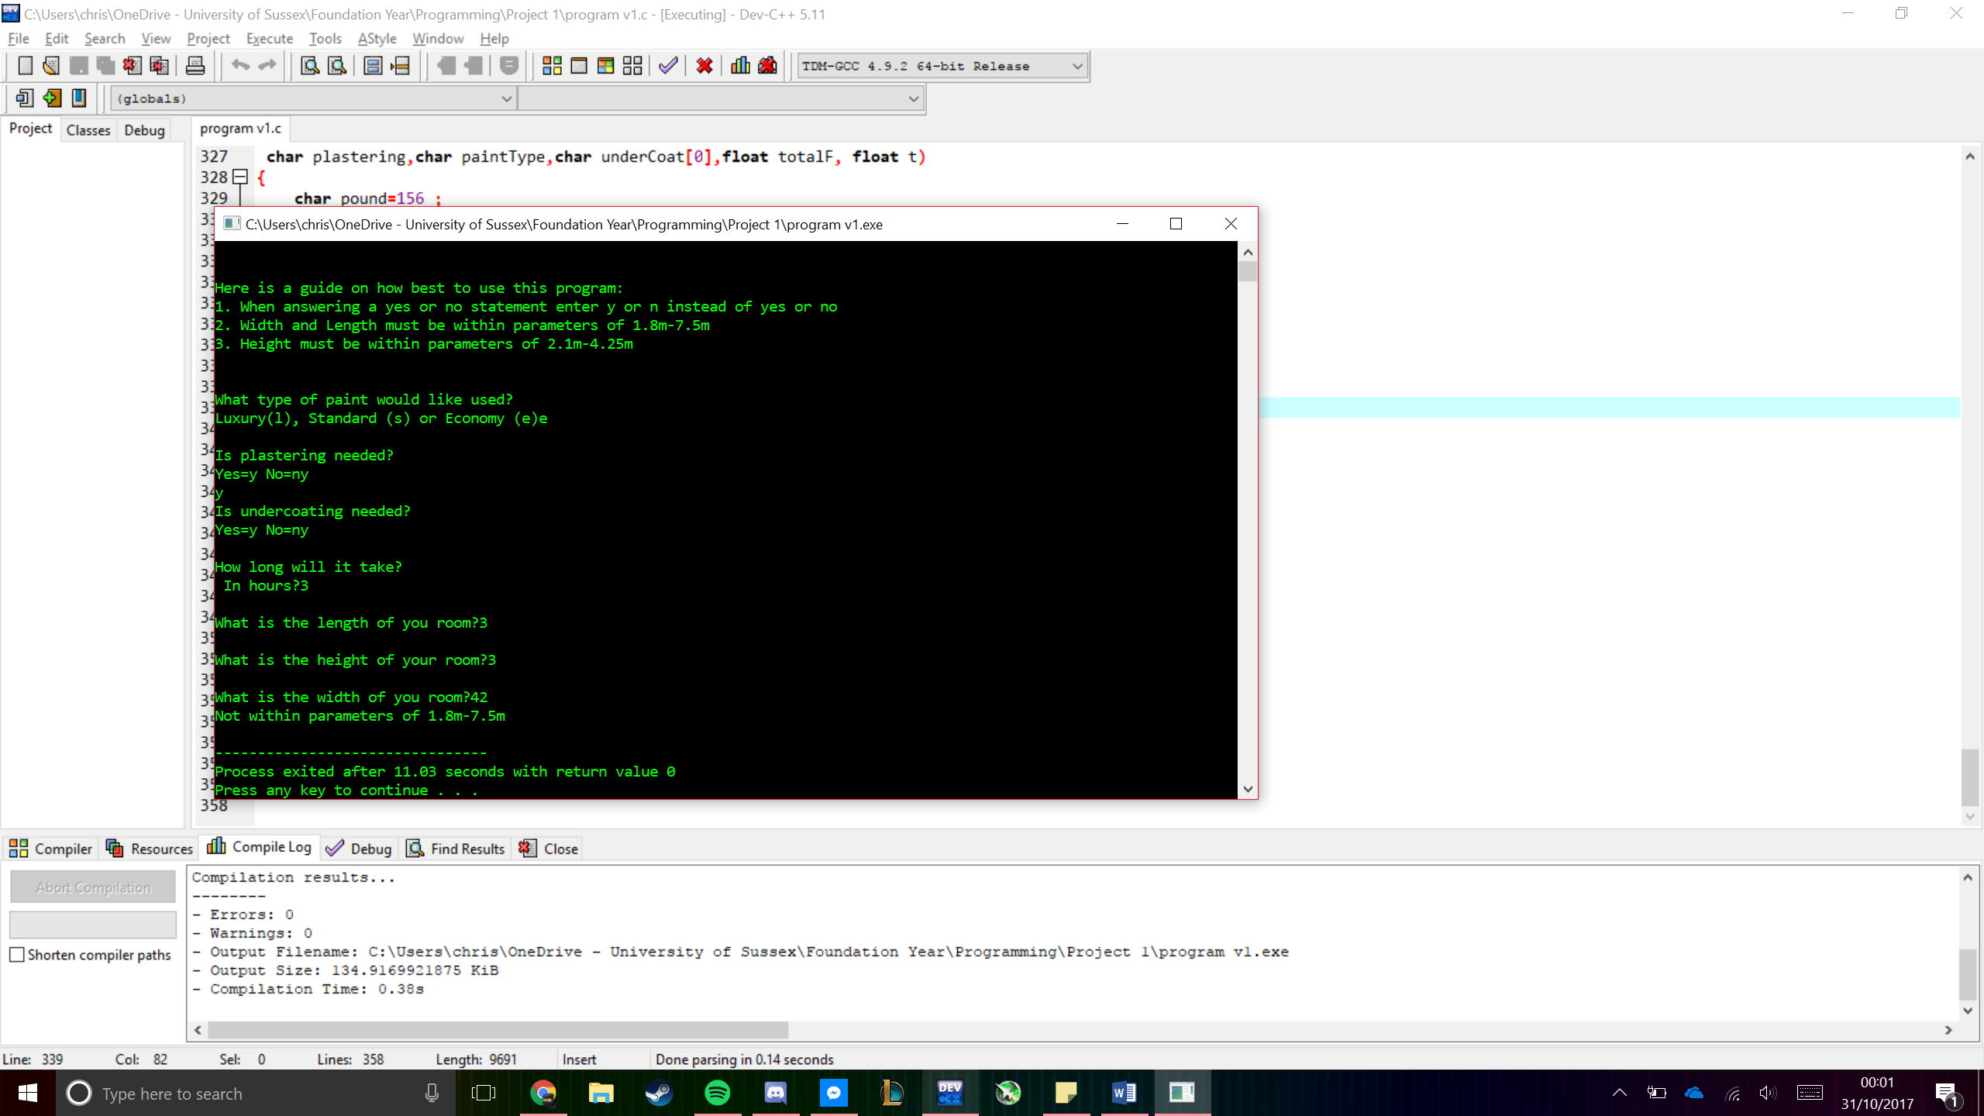

After entering a wrong character or integer the get paint type function shall realise and call itself therefore making it impossible to continue with the program unless the value is correct.

For an incorrect character

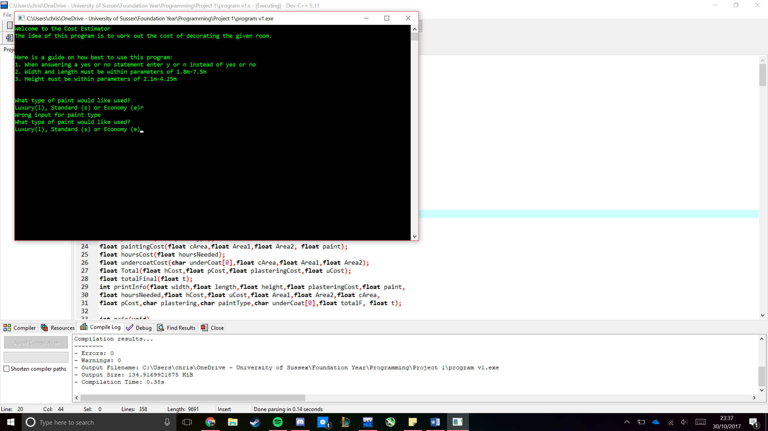

For an incorrect integer

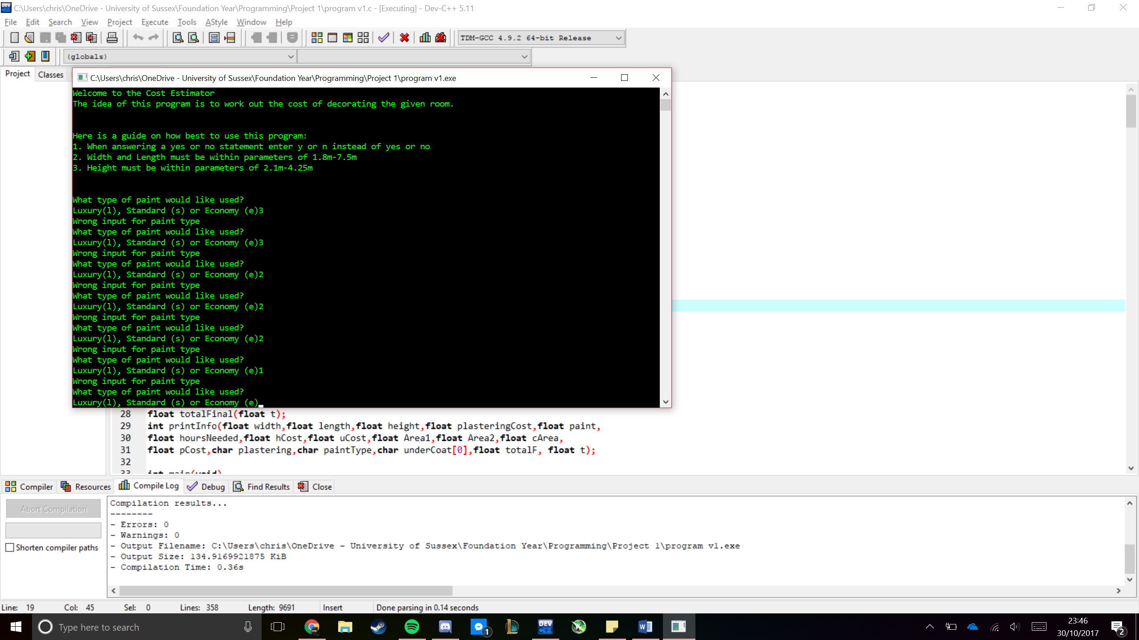

When the hours are entered into the system if a value over 100 is given then the program asks the user if they want to change their input.

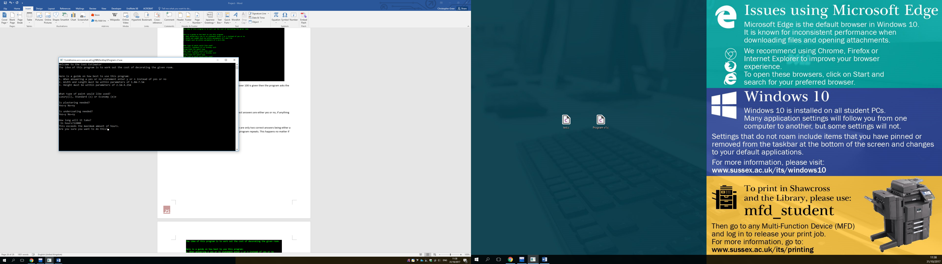

When the user is asked if they want plastering the correct answers are either yes or no, if anything other than these are entered the program repeats.

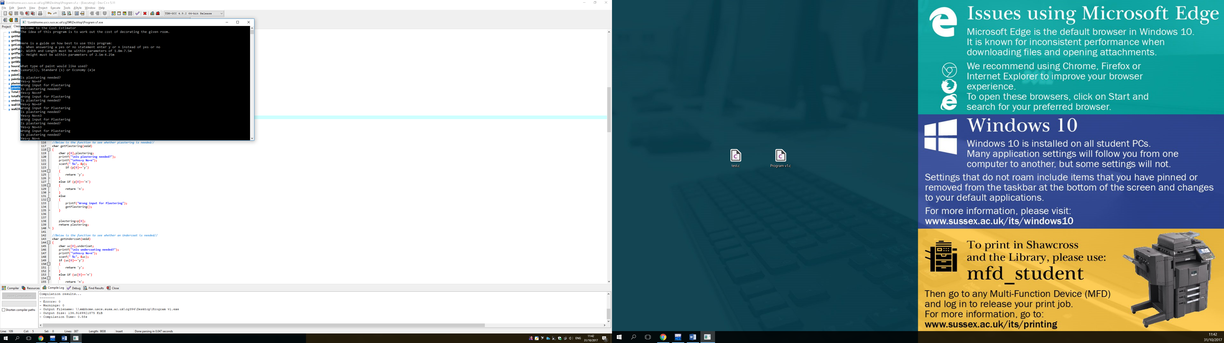

When the user is asked if they need undercoating there are only two correct answers being either a yes or no, if anything other than these are entered the program repeats. This happens no matter if it’s a character or an integer.

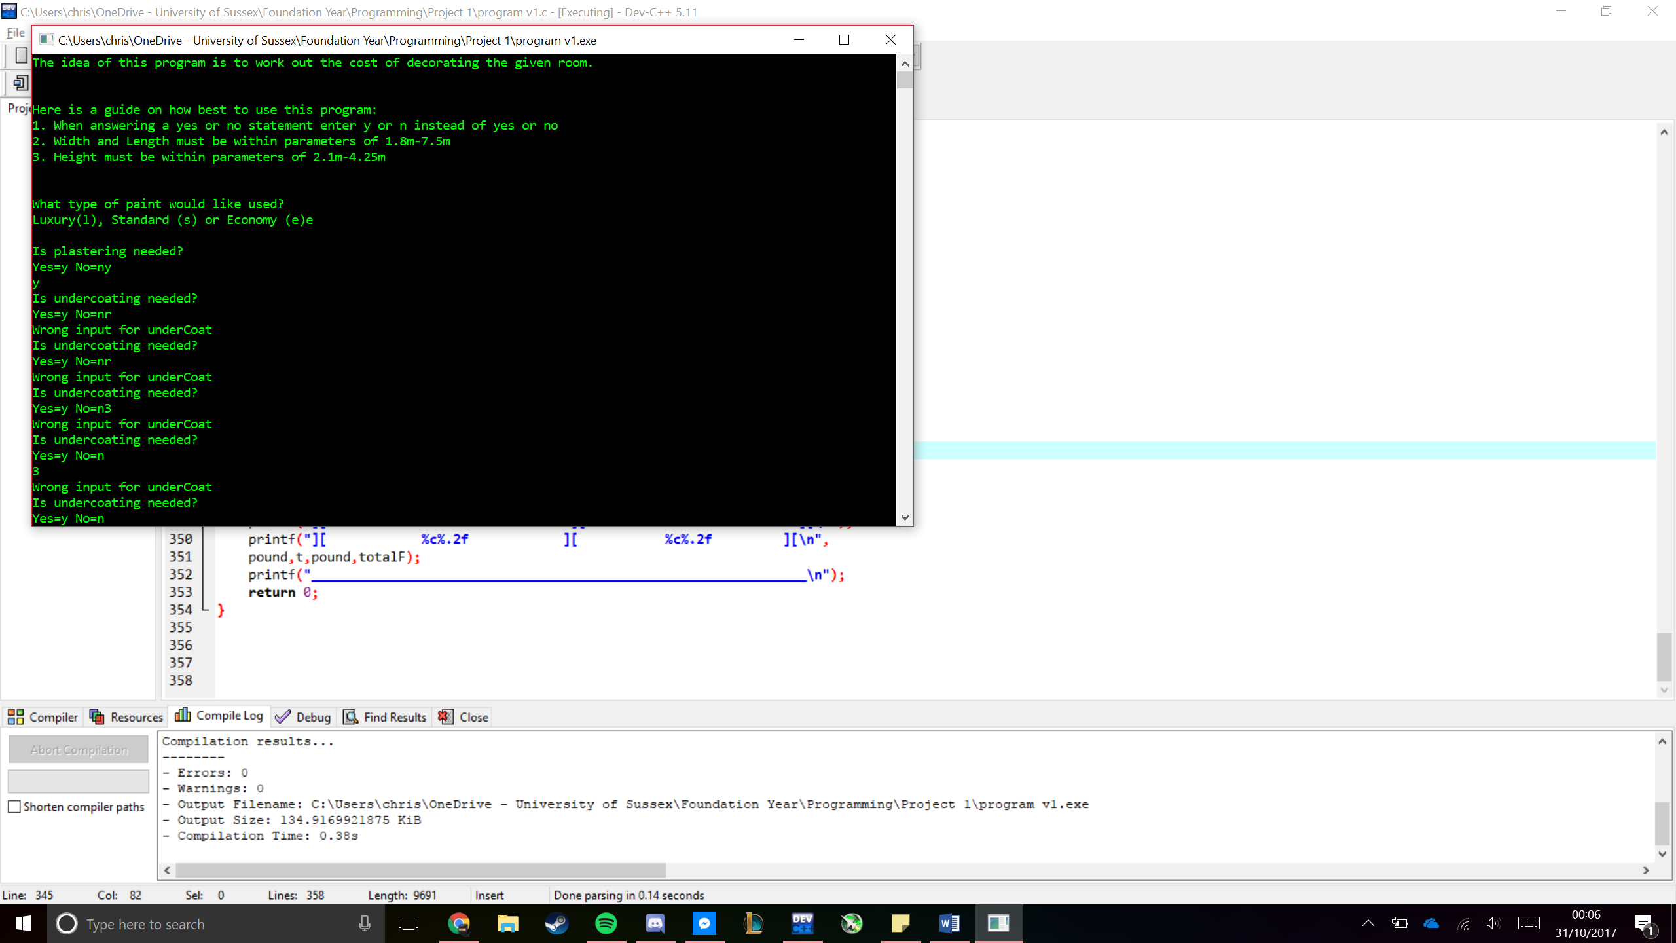

## Proof of Operation

### Proof 1

First test is with standard inputs that would be expected for this kind of program

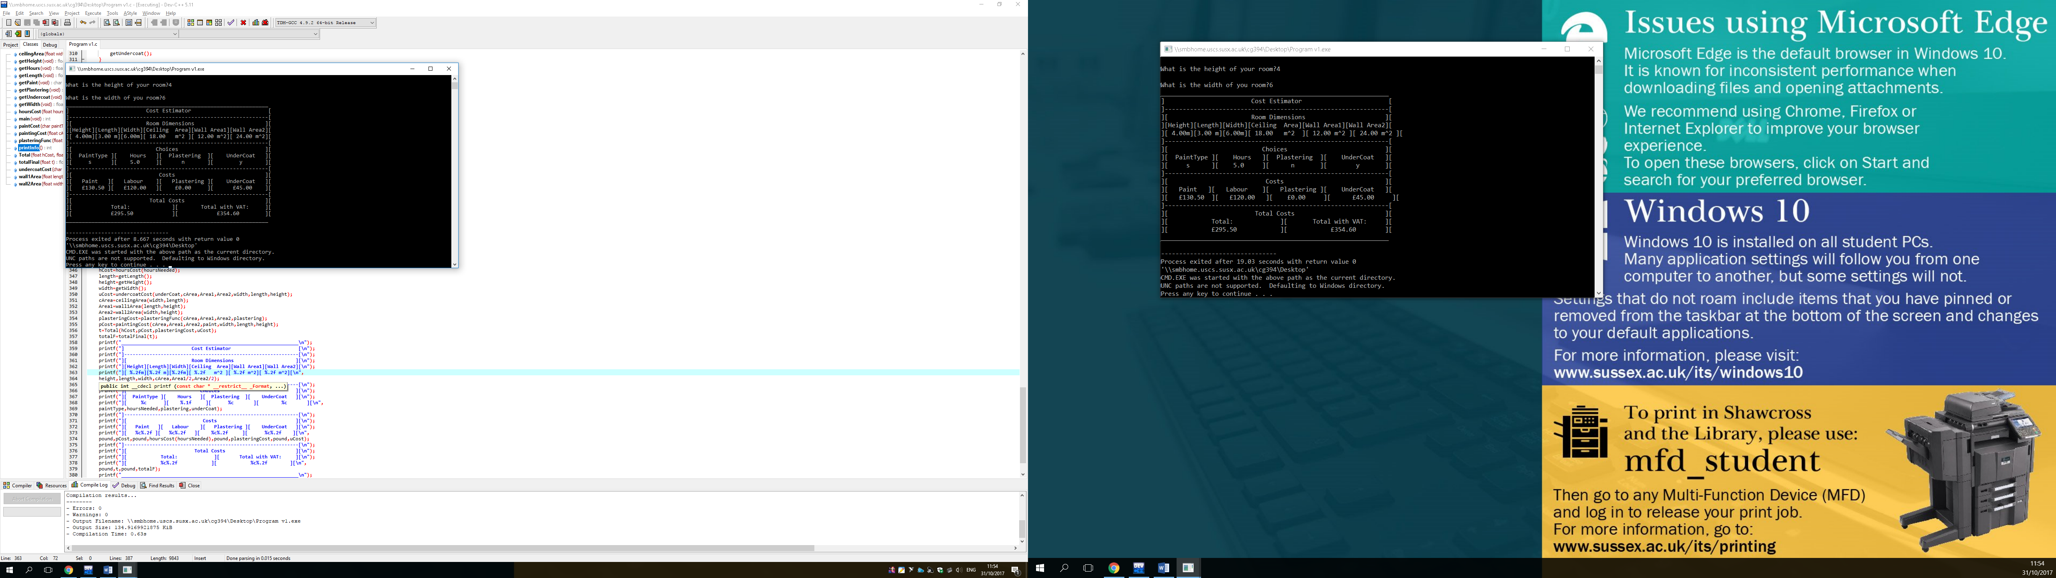

### Proof 2

The second test shows the maximum outputs that could be given by a user in this program

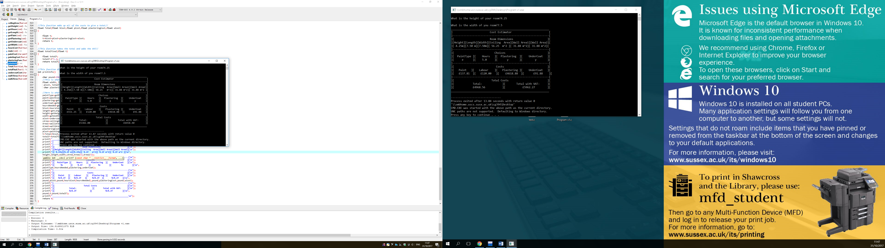

### Proof 3

The third test shows the minimum outputs that could be gained by a user from the estimator

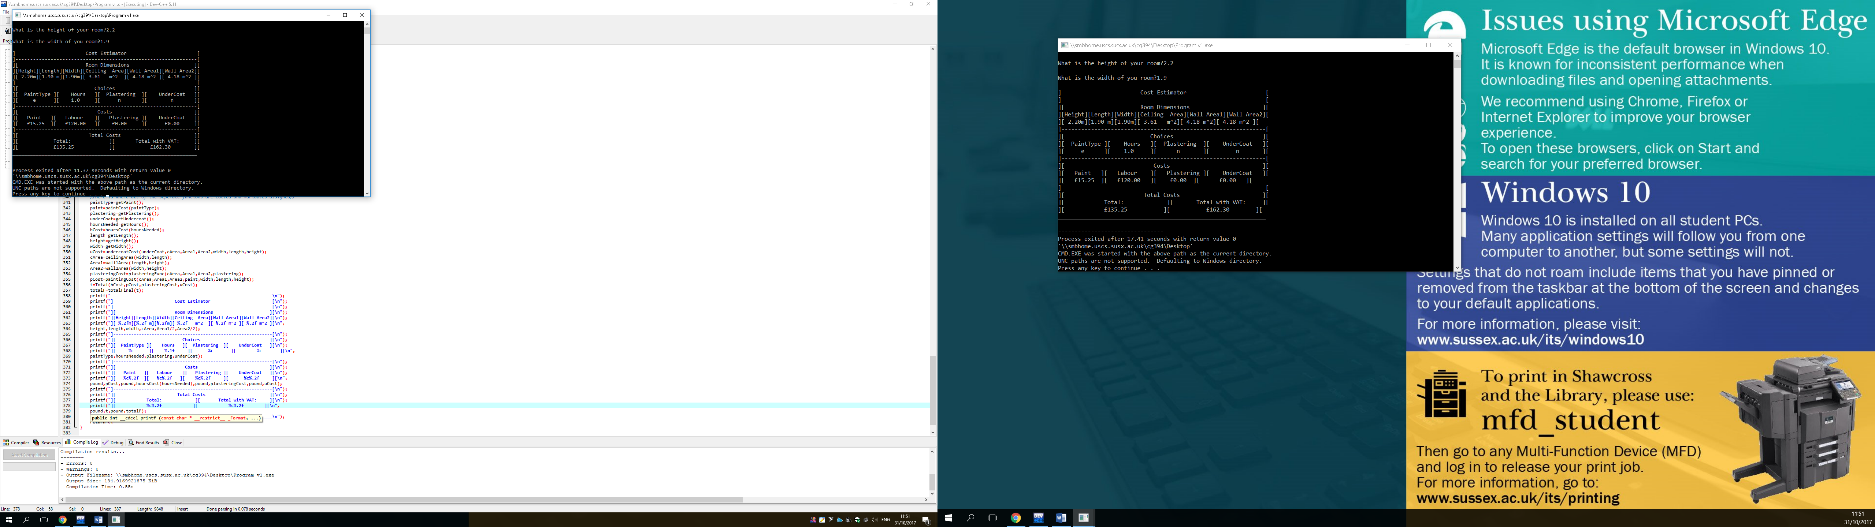

# Evaluation

The cost estimator that I have programmed is fully functional and is able to take in all values it is expected to and out put them in a UI that is easy and simple to read. Due to this I believe that the program is a success. In terms of improvements that could be made there are certain areas in the code that are messy or redundant that could be removed. This could be done but when removing some areas the code fell apart so I left all the code in the current places including the redundant parts.

During coding the program, the design changed quite a bit from the intended screen design. This is as the line symbols I originally had planned to use gave an unknown symbol resulting in my UI not looking correct. Instead I adopted square brackets which I think give it a much more robust look then the thin lines I had used originally and separates the content much better.

I had problems with certain values not being read in other functions such as width, length, height and the Areas. In order to overcome this, I changed the order of the code greatly from what I had originally planned to in my pseudo code and JSP.

I did have to research certain parts of the program such as if statements and arrays as we had not yet been taught them in lectures. I did this by the C programming book that had been recommended to us ad it gave clear explanations without too much help. Certain errors occurred that I didn’t understand, for these I googled the error which almost always sent me to stack over flow where I would read some ones’ description of the error. An example of this is where I had changed the parameters of a function and t told me that the 2nd assignment of the function differed. I had no clue what this meant at first but using the given definition I managed to work through.

I had great difficulty getting characters from my inputs as it would either crash or return weird shapes and characters. My problem here was the way I was taking the character and what I did with it. Therefore, I changed the way the characters were being saved, as I originally set them to an array, and instead switched them to standard variables. This can be seen as a weakness, but I believe that it stops the inputs from being too complicated. It is also included in the instructions how to use the program so this may not happen. All in all, I am happy with what I have accomplished